 | 8.3.1 Editors - Image Editor - Sidebar - Tool Tab in Paint Mode
Table of content
Detailed Table of Content 1
Tool Tab 7
Brush Asset Panel 7
Brush settings Panel 8
Brush Settings Panel - Color Picker Sub panel 12
Brush Settings Panel - Color Palette Sub panel 13
Brush Settings Panel - Advanced Sub panel 14
Brush Settings Panel - Texture Sub panel 17
Brush Settings Panel - Texture Mask Sub panel 22
Stroke Panel 26
Brush Settings Panel - Falloff Sub panel 33
Brush Settings Panel - Brush Tip Sub panel 35
Tiling panel 36

Detailed Table of Content

Detailed Table of Content
Detailed Table of Content 1
Tool Tab 7
Save Image 7
Brush Asset Panel 7
Browse Brush 7
Brush Specials menu 7
Edit Metadata 8
Catalog 8
Author 8
Desctription 8
OK / Cancel 8
Edit Preview Image 8
Save Brush Asset 8
Revert Brush Asset 8
Brush settings Panel 8
Blend 9
Size 9
Size Pressure 9
Pressure Size Curve 9
Selecting Points 9
Adding Points 9
Navigation elements 10
Zoom in 10
Zoom out 10
Clipping options 10
Tools 10
Reset View 10
Reset Curve 10
Handles 10
Position X / Y 10
Delete Points 10
Curve Presets 10
Use Unified Radius 10
Strength 10
Size Pressure 10
Pressure Size Curve 11
Selecting Points 11
Adding Points 11
Navigation elements 11
Zoom in 11
Zoom out 11
Clipping options 11
Tools 11
Reset View 11
Reset Curve 11
Handles 12
Position X / Y 12
Delete Points 12
Curve Presets 12
Use Unified Radius 12
Brush Settings Panel - Color Picker Sub panel 12
Brush colors flip 12
Use unified Color 12
Brush Settings Panel - Color Palette Sub panel 13
Palette browser 13
Edit Box 13
Number of users 13
Fake User 13
Add palette 13
Remove Palette 13
Brush Settings Panel - Advanced Sub panel 14
Brush type Draw 14
Anti Aliasing 14
Accumulate 14
Brush type Soften 14
Sharpen / Soften 14
Sharp Threshold 14
Kernel Radius 14
Blur Mode 15
Brush type Smear 15
Anti Aliasing 15
Brush type Clone 15
Anti Aliasing 15
Image 15
Alpha 15
Accumulate 15
Brush type Fill 15
Anti Aliasing 16
Brush type Mask 16
Anti Aliasing 16
Mask Value 16
Accumulate 16
Randomize Color subtab 16
Hue 16
Hue Jitter 16
Stroke Random 16
Use Pressure 16
Saturation 16
Saturation Jitter 16
Stroke Random 16
Use Pressure 17
Value 17
Value Jitter 17
Stroke Random 17
Use Pressure 17
Modes subpanel 17
Brush Settings Panel - Texture Sub panel 17
Texture Panel 17
Browse Texture to be linked 17
Texture Edit box 19
New Texture 19
Remove 19
Show Texture in Texture tab 19
Brush Mapping 19
Brush Mapping with mapping method Tiled 19
Angle 19
Offset 19
Size 19
Brush Mapping with mapping method View Plane 20
Angle 20
Rake 20
Random 20
Random Angle 20
Offset 20
Size 20
Brush Mapping with mapping method 3D 20
Offset 20
Size 20
Brush Mapping with mapping method Random 21
Angle 21
Rake 21
Random 21
Random Angle 21
Brush Mapping with mapping method Stencil 21
Image Aspect 22
Reset Transform 22
Angle edit box 22
Offset 22
Size 22
Brush Settings Panel - Texture Mask Sub panel 22
Texture Mask Panel 22
Browse Texture to be linked 22
Brush Mapping with mapping method Tiled 23
Pressure Masking 23
Angle 24
Offset 24
Size 24
Brush Mapping with mapping method View Plane 24
Pressure Masking 24
Angle 24
Rake 24
Random 24
Offset 24
Size 24
Brush Mapping with mapping method Random 24
Pressure Masking 25
Mask Pressure Mode 25
Angle 25
Rake 25
Random 25
Offset 25
Size 25
Brush Mapping with mapping method Stencil 25
Image Aspect 25
Reset Transform 25
Pressure Masking 26
Angle edit box 26
Offset 26
Size 26
Stroke Panel 26
Stroke Panel 26
Stroke method Space 26
Spacing Edit Box 26
Spacing Pressure 27
Adjust Strength for Spacing 27
Dash Ratio 27
Dash Length 27
Jitter Edit Box 27
Spacing Pressure 27
Jitter Unit 27
Input Samples Edit Box 27
Stabilize Stroke subpanel 27
Radius 27
Factor 27
Stroke method Curve 28
Spacing Edit Box 28
Paint Curve edit box 28
Draw Curve Button 29
Jitter Edit Box 29
Jitter Pressure 29
Jitter Unit 29
Input Samples Edit Box 29
Stabilize Stroke subpanel 29
Radius 29
Factor 29
Stroke method Line 29
Spacing Edit Box 30
Jitter Edit Box 30
Jitter Pressure 30
Jitter Unit 30
Input Samples Edit Box 30
Stabilize Stroke subpanel 30
Radius 30
Factor 30
Stroke method Anchored 30
Edge to edge 30
Jitter Edit Box 30
Jitter Pressure 30
Jitter Unit 31
Input Sample Edit Box 31
Stabilize Stroke subpanel 31
Radius 31
Factor 31
Stroke method Airbrush 31
Rate Edit Box 31
Jitter Edit Box 31
Jitter Pressure 31
Jitter Unit 31
Input Samples Edit Box 31
Stabilize Stroke subpanel 31
Radius 32
Factor 32
Stroke method Drag Dot 32
Jitter Edit Box 32
Jitter Pressure 32
Jitter Unit 32
Input Samples Edit Box 32
Stabilize Stroke subpanel 32
Radius 32
Factor 32
Stroke method Dots 33
Jitter Edit Box 33
Jitter Pressure 33
Jitter Unit 33
Input Samples Edit Box 33
Stabilize Stroke subpanel 33
Radius 33
Factor 33
Brush Settings Panel - Falloff Sub panel 33
Selecting Points 34
Adding Points 34
Navigation elements 34
Zoom in and out 34
Use Clipping 34
Tools 34
Reset View 34
Reset Curve 34
Curve window 34
Vector Handle 35
Auto Handle 35
X / Y values 35
Auto Clamped Handle 35
Delete Points 35
Curve Presets 35
Brush Settings Panel - Brush Tip Sub panel 35
Brush Tip Checkbox 35
Cursor Color 35
Falloff Opacity 36
Override Overlay 36
Use Cursor Overlay 36
Texture Opacity 36
Override Overlay 36
Use Cursor Overlay 36
Mask Texture Opacity 36
Override Overlay 36
Use Cursor Overlay 36
Tiling panel 36

Tool Tab

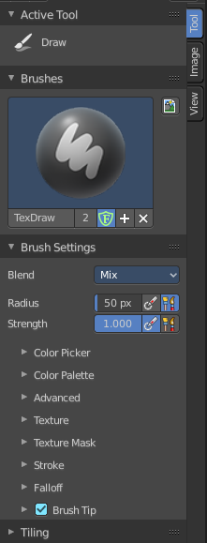
In View and Mask mode you don't have any further content in the Tool tab. But in Paint mode the tools tab contains several panels with functionality for the brushes. It is in big parts similar functionality to the paint tools in the 3D view.
The Brush panel shows different content, dependent of which brush is chosen in the tool shelf.

Save Image
A short warning. A modified image does NOT save with the scene. You have to save out the image when you want to save the changes at the texture. There is no warning. So DON'T FORGET TO SAVE THE IMAGE.

Brush Asset Panel
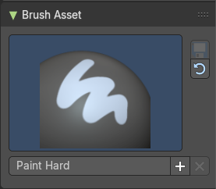
The Brush Asset Panel contains the different Brushes and some Brush settings. Choose and adjust your current active brush.

Browse Brush
The big image at the top is a dropdown box that allows you to choose a brush. Click at it, and you will see the different brushes. A click at one of the images will choose this brush then.
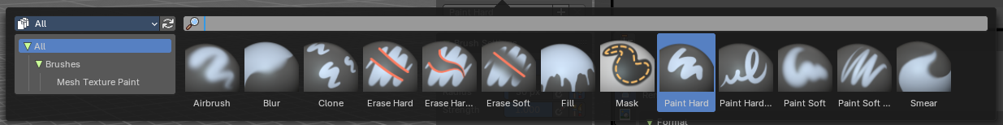
Brushes are assets. You can load them from different libraries if you want.

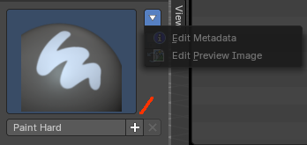
Brush Specials menu
This menu becomes active when you create a new brush. Which can be done wiht the Plus button in the name property. This data cannot be changed for builtin system brushes.

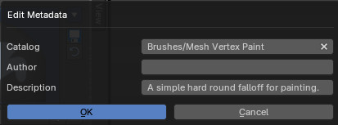
Edit Metadata
Calls a popup where you can adjust further informations and settings for the brush.

Catalog
The asset catalog in which the brush is stored.

Author
The brush author.

Desctription
Add a description

OK / Cancel
Accept or decline the changes.

Edit Preview Image
Allows you to load a custom preview image.

Save Brush Asset
This button is just active with a custom brush. It saves all changes made at the brush settings into the current custom brush.

Revert Brush Asset
Reverts the brush settings to the default values of the brush in the asset library.

Brush settings Panel

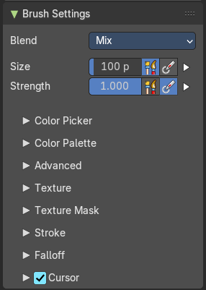
The Brush Panel contains the different paint brushes, a color dialog, and some brush settings.

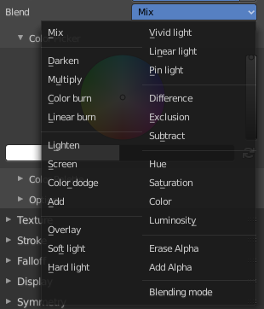
Blend
Define how the stroke will blend. You can choose between various blend modes.

Size
The Radius edit box allows you to adjust the radius of the brush. The button behind the edit box enables tablet pressure sensitivity for radius.

Size Pressure
The first button behind the edit box enables tablet pressure sensitivity for radius.

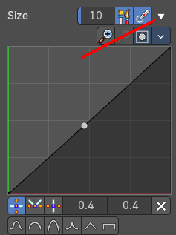
Pressure Size Curve
Behind the pressure size button there is a button to reveal the size pressure curve panel. When you activate Size Pressure for tablets, then the Size Pressure curve becomes active, and can be adjusted.
The pressure size curve allows you to adjust the falloff curve for the tablet pressure. It shows when Use Pressure is activated. The curve panel shows when clicking at the button.


Selecting Points
You can select curve points. This reveals two edit boxes for the x and y coordinate of this point.
Selected points can be moved around. Left click at them, hold the mouse button down and move them to a new location.


Adding Points
You can add new curve points by simply left clicking at the curve. Move the mouse to position them where you need it.

Navigation elements

Zoom in
Zooms in.

Zoom out
Zooms out.

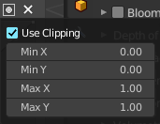
Clipping options
Set up clipping for the stroke.

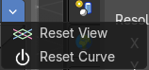
Tools
Tools is a menu where you can find some curve related tools.

Reset View
Resets the curve windows zoom.

Reset Curve
Resets the curve to the initial shape.

Handles
You can choose between Auto handle, Vector Handle and Auto Clamped.

Position X / Y
The position of the selectedc curve point.

Delete Points
Deletes the selected curve point.

Curve Presets
A curve preset to start with.

Use Unified Radius
The second button behind the edit box enables global radius size. Any modification at the radius will also modify the radius value for other paint tools.

Strength
The Strength edit box allows you to adjust the strength of the brush. The button behind the edit box enables tablet pressure sensitivity for strength.

Size Pressure
The first button behind the edit box enables tablet pressure sensitivity for radius.

Pressure Size Curve
Behind the pressure size button there is a button to reveal the size pressure curve panel. When you activate Size Pressure for tablets, then the Size Pressure curve becomes active, and can be adjusted.
The pressure size curve allows you to adjust the falloff curve for the tablet pressure. It shows when Use Pressure is activated. The curve panel shows when clicking at the button.

Selecting Points
You can select curve points. This reveals two edit boxes for the x and y coordinate of this point.
Selected points can be moved around. Left click at them, hold the mouse button down and move them to a new location.

Adding Points
You can add new curve points by simply left clicking at the curve. Move the mouse to position them where you need it.

Navigation elements

Zoom in
Zooms in.

Zoom out
Zooms out.

Clipping options
Set up clipping for the stroke.

Tools
Tools is a menu where you can find some curve related tools.

Reset View
Resets the curve windows zoom.

Reset Curve
Resets the curve to the initial shape.

Handles
You can choose between Auto handle, Vector Handle and Auto Clamped.

Position X / Y
The position of the selectedc curve point.

Delete Points
Deletes the selected curve point.

Curve Presets
A curve preset to start with.

Use Unified Radius
The second button behind the edit box enables global radius size. Any modification at the radius will also modify the radius value for other paint tools.

Brush Settings Panel - Color Picker Sub panel
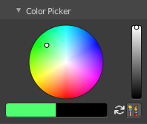
Define the color for your brush.
The active color is the left one. When you click the button with the two arrows down right then you can swap the color with the secondary color. Then this secondary color becomes the primary color, and is active.

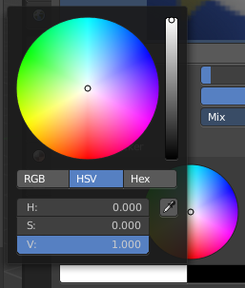
A click at one of the color fields will open a more detailed color dialog, to set up the color by using rgb, hsv and hex colors and with value sliders.

Brush colors flip
Flips the primary color with the secondary color.

Use unified Color
Choose if you want to use global colors or local color just for vertex painting.

Brush Settings Panel - Color Palette Sub panel

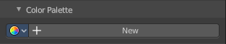
Create a color palette for later reuse.
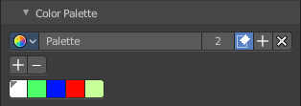
First create a new palette by clicking at New. Then adjust the color in the color picker. And then click at the add button to add this color to the palette.
To set the color picker to a palette color simply click at this palette color.
To remove a color from the palette, choose it, then click at the remove button. The active palette color that gets removed is the one with the triangle at it.
The color palette cannot be saved externally. It is part of the current blend file. You can however append color palettes from other blend files.
The elements are explained from left to right.

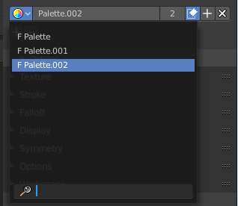
Palette browser
The button at the left opens a drop down list where you can choose between your palettes.

Edit Box
Read the name of the currently active palette. You can also rename the palette here. A click into the edit box makes the name editable.

Number of users
See how many users the palette currently has.

Fake User
Fake User sets the element to have a fake user. Zero user data-blocks are normally not saved. But sometimes you want to force the data to be kept even when the data block has no user.

Add palette
Add a new palette.

Remove Palette
Clicking at this button removes the palette. Note that you need to save, close Bforartists and reload the blend file to remove the palette completely.

Brush Settings Panel - Advanced Sub panel
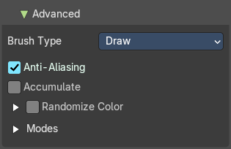
This sub panel contains brush specific settings.

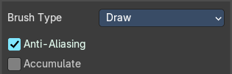
Brush type Draw
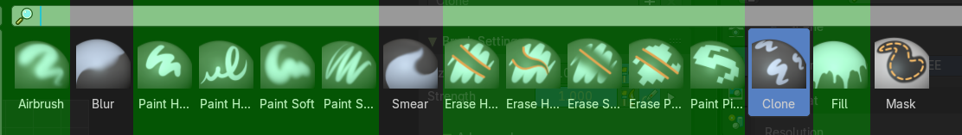

Anti Aliasing
Smooths the edges of the strokes.

Accumulate
Accumulate stroke daubs on top of each other.

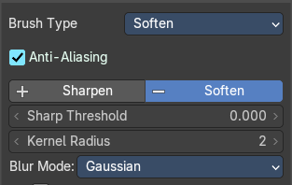
Brush type Soften

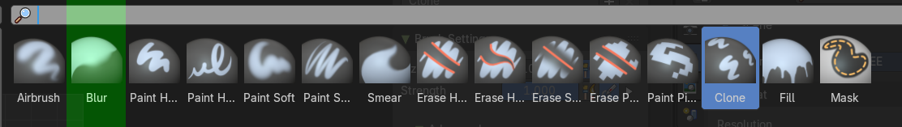

Sharpen / Soften

Sharp Threshold
The threshold below which no sharpening is performed.

Kernel Radius
Radius of kernel used for soften and sharpen in pixels.

Blur Mode
Choose the blur method. Gaussian or Box.

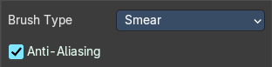
Brush type Smear
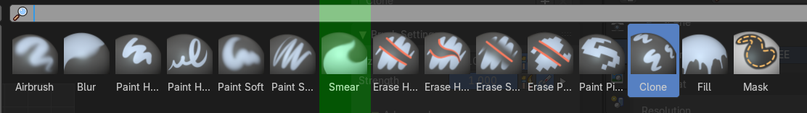

Anti Aliasing
Smooths the edges of the strokes.

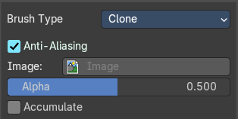
Brush type Clone

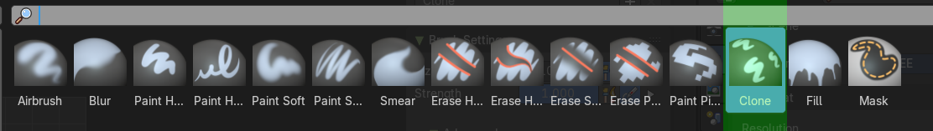

Anti Aliasing
Smooths the edges of the strokes.

Image
Choose an image to clone from.

Alpha
The alpha value for the clone image.

Accumulate
Accumulate stroke daubs on top of each other.

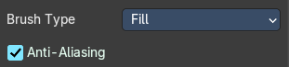
Brush type Fill
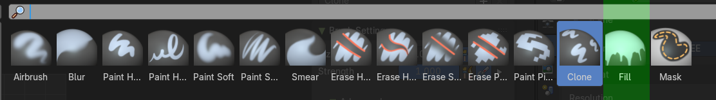

Anti Aliasing
Smooths the edges of the strokes.

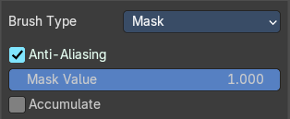
Brush type Mask
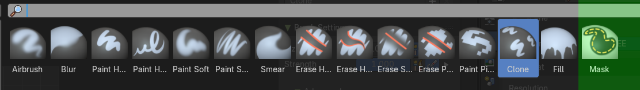

Anti Aliasing
Smooths the edges of the strokes.

Mask Value
The vertex weight when brush is applied.

Accumulate
Accumulate stroke daubs on top of each other.

Randomize Color subtab
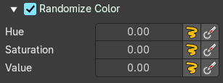
Jitter the brush color.

Hue

Hue Jitter
The amount to jitter the Hue value.

Stroke Random
Activate the Jitter.

Use Pressure
Use tablet pressure when drawing.

Saturation

Saturation Jitter
The amount to jitter the Saturation value.

Stroke Random
Activate the Jitter.

Use Pressure
Use tablet pressure when drawing.

Value

Value Jitter
The amount to jitter the Value value.

Stroke Random
Activate the Jitter.

Use Pressure
Use tablet pressure when drawing.

Modes subpanel
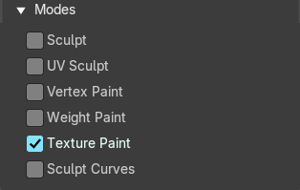
In which mode to use the brushes.

Brush Settings Panel - Texture Sub panel
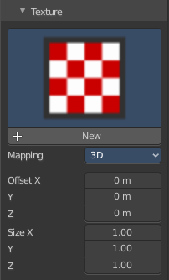

Texture Panel
The Texture panel allows you to paint with textures. This allows you for example to grab a photo from some fish scales, and simply paint them onto the mesh by using this image as a pencil. Or as a blueprint where you calk through ( Stencil method ).

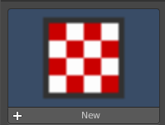
Browse Texture to be linked
The image at the top of the panel is an image browser. Choose a texture that you can choose for painting then. You can also have more than one image loaded at once.
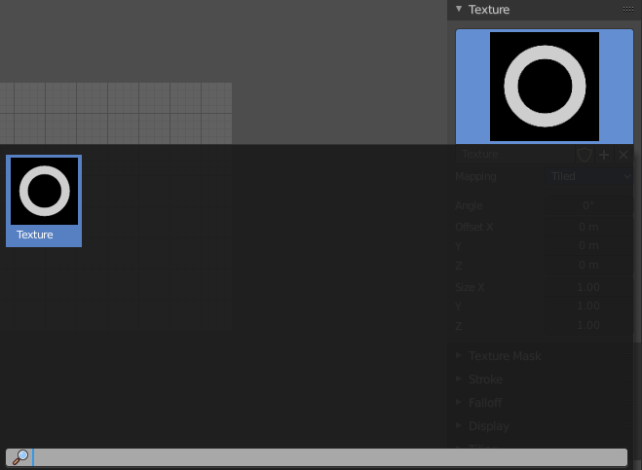
In this shot there is already a texture added. The way to add the texture here is a bit more complicated. And not done with clicking at the New button.

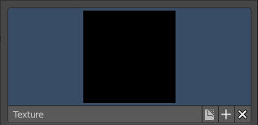
First click at the New button below the image. This will create a new texture slot. This slot is still empty, it displays black.
We need to load a texture in this slot. This must be done in the Properties editor in the Textures tab.
The problem is, we have most probably an object with a material and a texture already selected. And when we change this texture , then we don't get the pencil texture loaded. But we change the texture at our mesh.
What we need to do is to create a material first. And in this material we load our pencil texture then. And then this texture becomes available in the image browser of the Texture panel. Note that you need to be in texture paint mode to see the texture tab in the properties editor. It does not show in object mode.
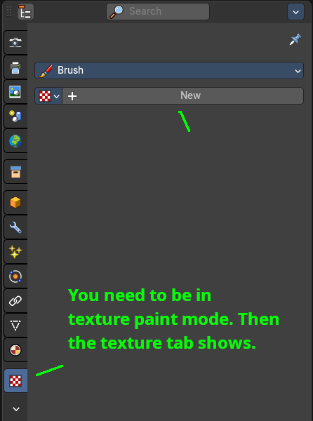
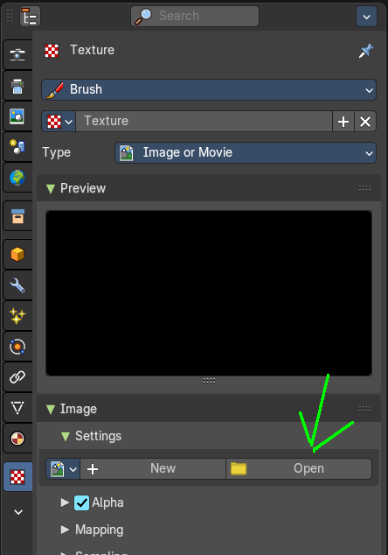
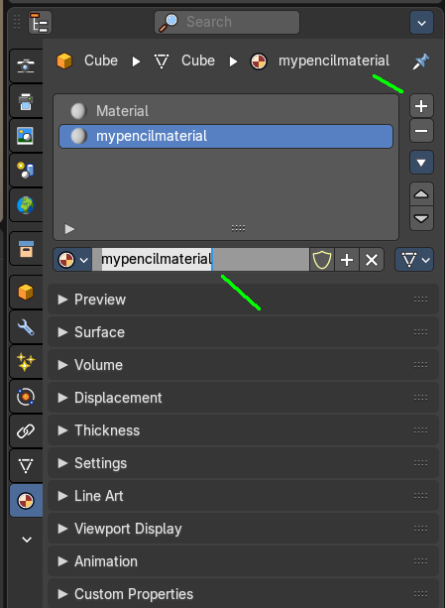
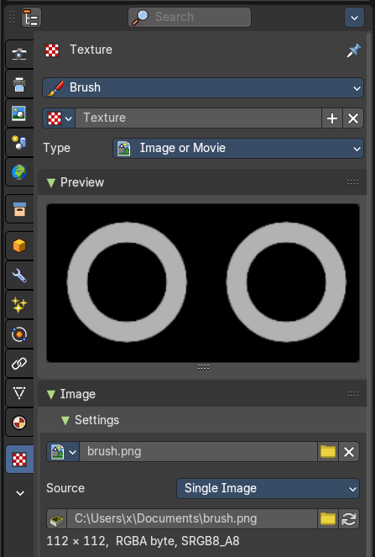

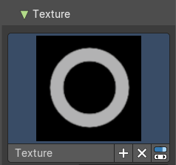
And when we go back to the texture panel, then the texture should be loaded here. And we can work with this texture.

Texture Edit box
The Texture edit box is the edit box below the Image browser. When there's no image loaded then it displays the New button. When there's an image (or more) loaded, then you will see the name of the current texture.

New Texture
Creates a duplicate of the current texture.

Remove
Removes the current texture.

Show Texture in Texture tab
Reveals the current texture in the texture tab in the properties editor.

Brush Mapping
Our texture can be mapped in different methods. The Brush mapping is a drop down box where you can choose this different brush mapping methods.
The settings vary. So we will go through them by the different brush mapping methods.

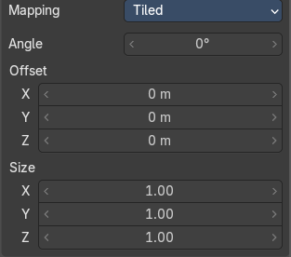
Brush Mapping with mapping method Tiled
The brush mapping method Tiled tiles the brush stroke at the surface. The mapping happens from the current view. The result may be distorted when the view does not align with the surface of the object.

Angle
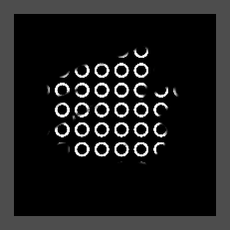
The angle of the brush.

Offset
The offset of the texture in the brush.

Size
The size of the texture in the brush.

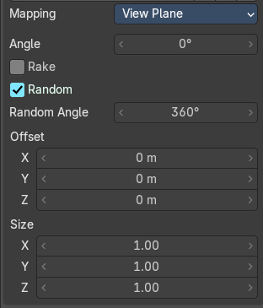
Brush Mapping with mapping method View Plane
The brush mapping method View Plane simply paints onto the surface. The mapping happens from the current view. The result may be distorted when the view does not align with the surface of the object.

Angle
The angle of the brush.

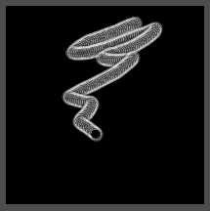
Rake
The angle follows the direction of the brush stroke.

Random
The brush angle gets set random.

Random Angle
Brush texture random angle.

Offset
The offset of the texture in the brush.

Size
The size of the texture in the brush.

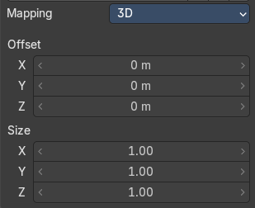
Brush Mapping with mapping method 3D
The brush mapping method 3D paints the texture at the surface, by tiling it 1/1 at the object surface.

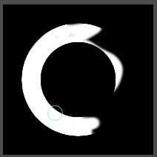
Offset
The offset of the texture in the brush.

Size
The size of the texture in the brush.

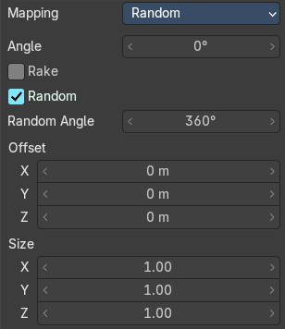
Brush Mapping with mapping method Random
The brush mapping method Random paints onto the surface, and randomizes the texture position in the brush while that. The mapping happens from the current view. The result may be distorted when the view does not align with the surface of the object.

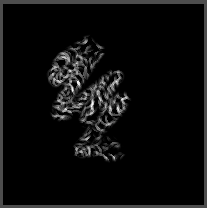
Angle
The angle of the brush.

Rake
The angle follows the direction of the brush stroke.

Random
The brush angle gets set random.

Random Angle
Brush texture random angle.

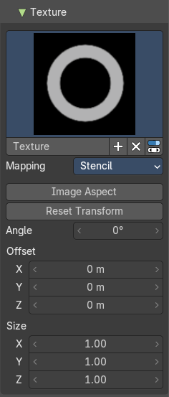
Brush Mapping with mapping method Stencil
The former methods uses the textures for the brush. The method Stencil works different. You have your texture displayed in the workspace above the object, and you paint this texture onto your object with your pencil strokes.
Note that the texture in the 3d space is just visible when you are with the mouse over the viewport.
The stencil map gets by default displayed down left in the 3d view. You have to position it where you need it.
Hotkeys ctrl right mouse, shift right mouse and alt right mouse.
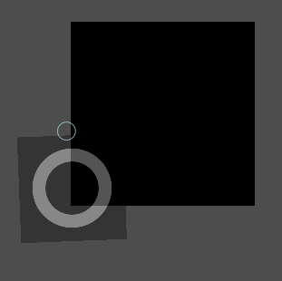

Image Aspect
Adjust the stencil size to fit to the image aspect ratio.

Reset Transform
Resets the stencil image to be down right in the 3D view.

Angle edit box
Adjust the angle of the brush.

Offset
Fine tune the offset of the texture in the brush.

Size
Fine tune the size of the texture in the brush.

Brush Settings Panel - Texture Mask Sub panel

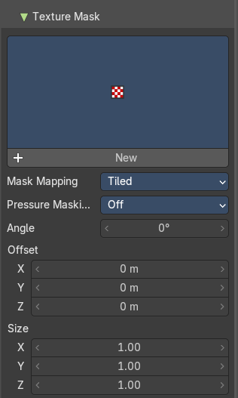
Texture Mask Panel
The texture mask panel allows you to use a texture as a mask to define the strength of painting. It paints just where the mask texture is bright. You can also use gradients to define the paint strength.

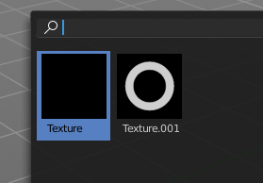
Browse Texture to be linked
The image at the top of the panel is an image browser. Choose a texture that you can choose for painting then. You can also have more than one image loaded at once.

In this shot there is already two textures added. The way to add the texture here is a bit more complicated. And not done with clicking at the New button.
First click at the New button below the image. This will create a new texture slot. This slot is still empty, it displays black.
We need to load a texture in this slot. This must be done in the Properties editor in the Textures tab.
The problem is, we have an object with a material and a texture already selected. And when we change this texture , then we don't get the pencil texture loaded. But we change the texture at our mesh.
What we need to do is to create a material first. And in this material we load our pencil texture then. And then we can choose this texture in the image browser of the texture.

And when we switch back to the tools tab, then the texture is loaded. And we can work with this texture.

Make sure that you use another texture in the Texture panel than in the Texture Mask panel, or no texture at all. When both is the same then you will get the same result with all Mask Mapping methods since they overlap each other at the very same positions.

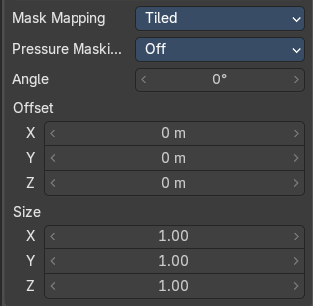
Brush Mapping with mapping method Tiled
The brush mapping method Tiled tiles the brush stroke at the surface. The mapping happens from the current view. The result may be distorted when the view does not align with the surface of the object.

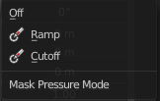
Pressure Masking
Enable pressure masking when you use a tablet.

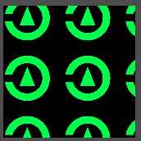
Angle
The angle of the brush.

Offset
The offset of the texture in the brush.

Size
The size of the texture in the brush.

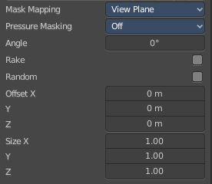
Brush Mapping with mapping method View Plane
The brush mapping method View Plane simply paints onto the surface. The mapping happens from the current view. The result may be distorted when the view does not align with the surface of the object.

Pressure Masking
Enable pressure masking when you use a tablet.

Angle
The angle of the brush.

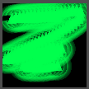
Rake
The angle follows the direction of the brush stroke.

Random
The brush angle gets set random.

Offset
The offset of the texture in the brush.

Size
The size of the texture in the brush.

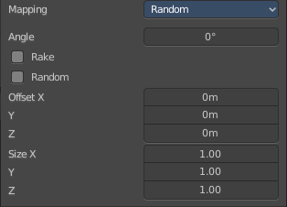
Brush Mapping with mapping method Random
The brush mapping method Random paints onto the surface, and randomizes the texture position in the brush while that.

Pressure Masking
Enable pressure masking when you use a tablet.

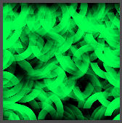
Mask Pressure Mode
A drop down box to choose the mask pressure mode for tablets.

Angle
The angle of the brush.

Rake
The angle follows the direction of the brush stroke.

Random
The brush angle gets set random.

Offset
The offset of the texture in the brush.

Size
The size of the texture in the brush.

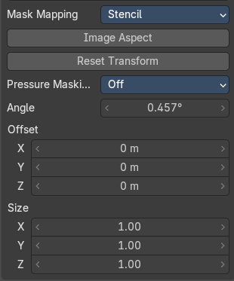
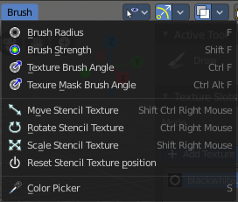
Brush Mapping with mapping method Stencil
The former methods uses the textures for the brush. The method Stencil works different. You have your texture displayed in the workspace above the image, and you paint this texture onto your object with your pencil strokes.
Note that the stencil texture is just visible when you are with the mouse over the viewport. It gets by default displayed down left. You have to position it where you need it. See Brush menu, Stencil Texture controls.

Image Aspect
Adjust the stencil size to fit to the image aspect ratio.

Reset Transform
Resets the stencil image to be down right in the 3D view.

Pressure Masking
Enable pressure masking when you use a tablet.

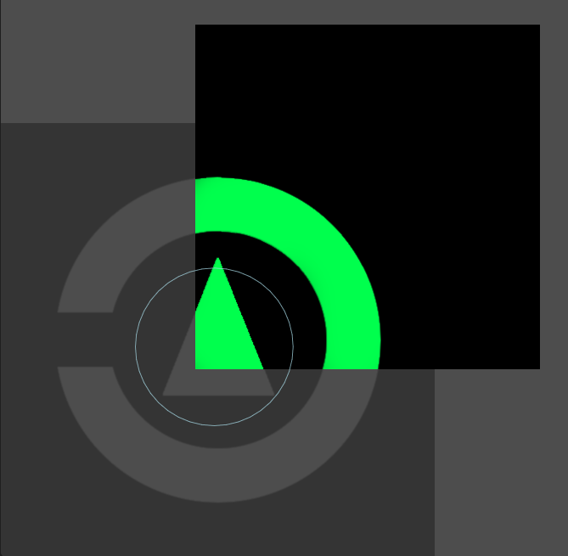
Angle edit box
Adjust the angle of the brush. The button at the end allows you to set the radius by dragging the mouse. This should be done in the viewport and with the hotkey. This button is just a visible reminder.

Offset
Fine tune the offset of the texture in the brush.

Size
Fine tune the size of the texture in the brush.

Stroke Panel

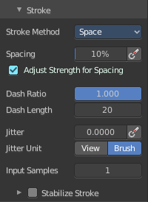
Stroke Panel
The Stroke panel contains settings to influence the behavior of the brush stroke. There are various stroke methods available. We will go through them one by one.

Stroke method Space
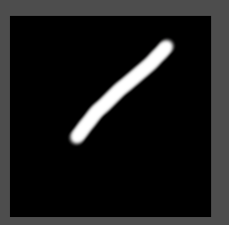
This is the default Stroke method. The stroke gets added continuously with given settings.


Spacing Edit Box
The sculpt drawing happens by mapping the pencil onto the mouse position. And when you move the mouse then the next mapping happens. Adjust the spacing after what mouse movement the next mapping should happen. The lower the value, the lower the distance between the single dots.

Spacing Pressure
The icon behind the edit box enables tablet pressure sensitivity for tablets.

Adjust Strength for Spacing
Automatically adjust strength to give consistent results for different spacing.

Dash Ratio
Ratio of samples in a cycle that the brush is covering.

Dash Length
Length of a dash cycle measured in stroke samples.

Jitter Edit Box
Add Jitter to the brush while painting.

Spacing Pressure
The icon behind the edit box enables tablet pressure sensitivity for tablets.

Jitter Unit
Jitter in screen space, or relative to the brush size.

Input Samples Edit Box
Average multiple input samples together to smooth the brush stroke.

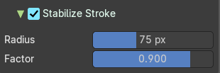
Stabilize Stroke subpanel
The brush lags behind the mouse position, and produces a much smoother stroke by that.

Radius
Adjust the radius of the smoothing.

Factor
Adjust the factor of the smoothing.

Stroke method Curve
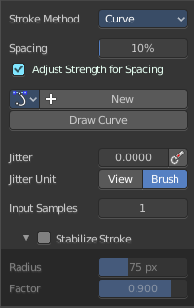
The Stroke method curve doesn't simply influence the way how the stroke is painted. It is a special method.
First you draw a curve object by holding down ctrl and clicking with right mouse button. Then you tweak the curve. You can click at the curve point, and drag out handlers to make the curve points smooth. This way you get one handler. When you click and drag then you will get two handlers at the curve point.
When done you hit the Draw Curve button or click left outside of the image. And the curve gets drawn onto the surface.
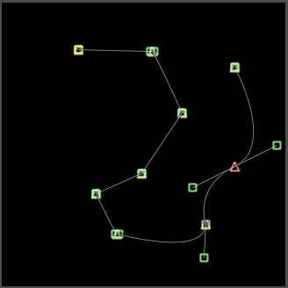
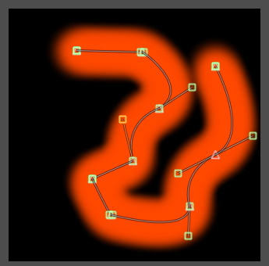

Spacing Edit Box
The drawing happens by mapping the pencil onto the mouse position. And when you move the mouse then the next mapping happens. Adjust the spacing after what mouse movement the next mapping should happen. The lower the value, the lower the distance between the single dots.
The icon behind the edit box enables tablet pressure sensitivity for tablets.

Paint Curve edit box
Here you set the active curve.
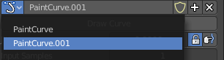
The first element is a drop down box where you will find your curves objects. You can have more than one.
The second element is the edit box that displays the active curve.
The number right of it, in this case 2, indicates how much number of users ( internally ) this brush uses. This means that this data block (the brush) shares currently settings with at least one other object. Most probably the parent brush where we have created it from. Click at the value to make this brush a single user. The button will vanish then.
F set the brush to have a fake user. Zero user data-blocks are normally not saved. But sometimes you want to force the data to be kept even when the data block has no user.
The + button allows you to add a new pencil with the current settings. Note that the brushes are NOT saved when you close Bforartists. You can save them into the current blend file. Or you can save the startup file. But be careful here. This saves everything else of the current state of Bforartists too.
The X button deletes the brush as the active one. It does NOT delete it from the brushes list.

Draw Curve Button
A click at it to turns the curve into curve.

Jitter Edit Box
Add Jitter to the brush while painting.

Jitter Pressure
The icon behind the edit box enables tablet pressure sensitivity for tablets.

Jitter Unit
Jitter in screen space, or relative to the brush size.

Input Samples Edit Box
Average multiple input samples together to smooth the brush stroke.

Stabilize Stroke subpanel
The brush lags behind the mouse position, and produces a much smoother stroke by that.

Radius
Adjust the radius of the smoothing.

Factor
Adjust the factor of the smoothing.

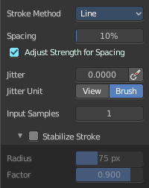
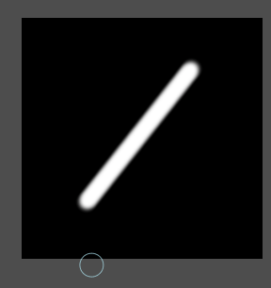
Stroke method Line
With Stroke method line you draw a line between a starting point and an endpoint. And when you release the mouse then the line gets drawn.

Spacing Edit Box
The drawing happens by mapping the pencil onto the mouse position. And when you move the mouse then the next mapping happens. Adjust the spacing after what mouse movement the next mapping should happen. The lower the value, the lower the distance between the single dots.
The icon behind the edit box enables tablet pressure sensitivity for tablets.

Jitter Edit Box
Add Jitter to the brush while painting.

Jitter Pressure
The icon behind the edit box enables tablet pressure sensitivity for tablets.

Jitter Unit
Jitter in screen space, or relative to the brush size.

Input Samples Edit Box
Average multiple input samples together to smooth the brush stroke.

Stabilize Stroke subpanel
The brush lags behind the mouse position, and produces a much smoother stroke by that.

Radius
Adjust the radius of the smoothing.

Factor
Adjust the factor of the smoothing.

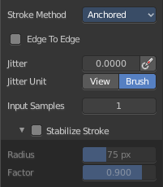
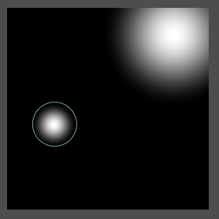
Stroke method Anchored
Click and drag to place a dot and to scale it.

Edge to edge
Drag Anchor Brush from edge to edge.

Jitter Edit Box
Add Jitter to the brush while painting.

Jitter Pressure
The icon behind the edit box enables tablet pressure sensitivity for tablets.

Jitter Unit
Jitter in screen space, or relative to the brush size.

Input Sample Edit Box
Average multiple input samples together to smooth the brush stroke.

Stabilize Stroke subpanel
The brush lags behind the mouse position, and produces a much smoother stroke by that.

Radius
Adjust the radius of the smoothing.

Factor
Adjust the factor of the smoothing.

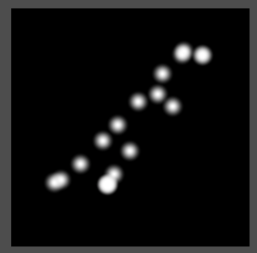
Stroke method Airbrush
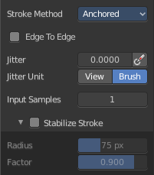
The stroke acts like an airbrush pencil. The dots gets placed randomly.

Rate Edit Box
Define the rate of the drawing.

Jitter Edit Box
Add Jitter to the brush while painting.

Jitter Pressure
The icon behind the edit box enables tablet pressure sensitivity for tablets.

Jitter Unit
Jitter in screen space, or relative to the brush size.

Input Samples Edit Box
Average multiple input samples together to smooth the brush stroke.

Stabilize Stroke subpanel
The brush lags behind the mouse position, and produces a much smoother stroke by that.

Radius
Adjust the radius of the smoothing.

Factor
Adjust the factor of the smoothing.

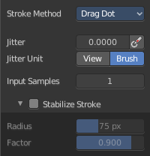
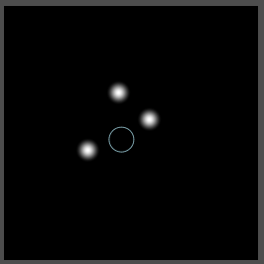
Stroke method Drag Dot
Paint a dot and drag it around. The actual painting happens then at releasing the mouse.

Jitter Edit Box
Add Jitter to the brush while painting.

Jitter Pressure
The icon behind the edit box enables tablet pressure sensitivity for tablets.

Jitter Unit
Jitter in screen space, or relative to the brush size.

Input Samples Edit Box
Average multiple input samples together to smooth the brush stroke.

Stabilize Stroke subpanel
The brush lags behind the mouse position, and produces a much smoother stroke by that.

Radius
Adjust the radius of the smoothing.

Factor
Adjust the factor of the smoothing.

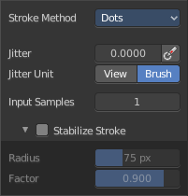
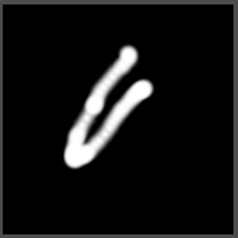
Stroke method Dots
The stroke method Dots draws dots of the pencil onto the surface. The mapping happens from the current view. Means you will get distortions when your view is not aligned with the surface of the object.

Jitter Edit Box
Add Jitter to the brush while painting.

Jitter Pressure
The icon behind the edit box enables tablet pressure sensitivity for tablets.

Jitter Unit
Jitter in screen space, or relative to the brush size.

Input Samples Edit Box
Average multiple input samples together to smooth the brush stroke.

Stabilize Stroke subpanel
The brush lags behind the mouse position, and produces a much smoother stroke by that.

Radius
Adjust the radius of the smoothing.

Factor
Adjust the factor of the smoothing.

Brush Settings Panel - Falloff Sub panel
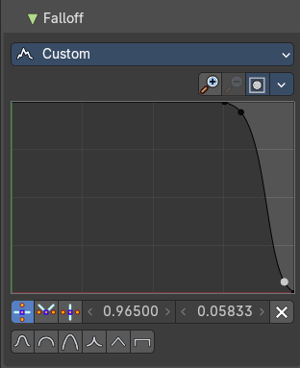
The curve panel allows you to define different falloffs methods for the border of the brush.

Selecting Points
You can select curve points. This reveals two edit boxes for the x and y coordinate of this point.
Selected points can be moved around. Left click at them, hold the mouse button down and move them to a new location.

Adding Points
You can add new curve points by simply left clicking at the curve. Move the mouse to position them where you need it.

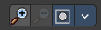
Navigation elements
The navigation elements at the top are described from left to right.

Zoom in and out
The two buttons with the magnifying glass at it zooms in and out in the curve window.

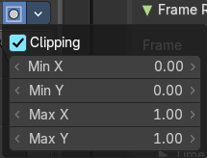
Use Clipping
Clipping options. Set up clipping for the stroke.

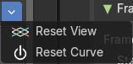
Tools
Tools is a menu where you can find some curve related tools.

Reset View
Resets the curve windows zoom.

Reset Curve
Resets the curve to the initial shape.

Curve window
Tweak and adjust the falloff curve by clicking at a curve point and dragging it around.
Double click adds a new point.
Holding down ctrl activates temporary snapping.
Holding down shift enables slower movement, which allows more accurate setting.

Vector Handle
Set handle type to Vector.

Auto Handle
Set handle type to Auto.

X / Y values
The position of the currently selected curve point.

Auto Clamped Handle
Set handle type to Auto Clamped.

Delete Points
Deletes selected curve points.


Curve Presets
Predefined curve presets.

Brush Settings Panel - Brush Tip Sub panel

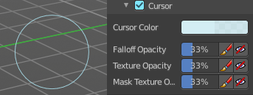
Adjust the color and appearance of the brush cursor to custom values.

Brush Tip Checkbox
Activate the custom settings.

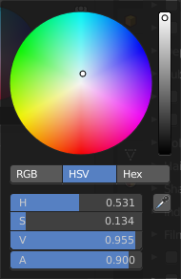
Cursor Color
Choose another color for the brush cursor. Double clicking at the color field will open a color picker.

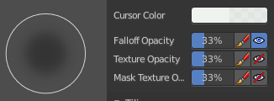
Falloff Opacity
You can turn on the cursor overlay with the eye button at the end. The falloff opacity slider allows you to adjust the opacity of this cursor overlay.

Override Overlay
Hide the Cursor Overlay when painting.

Use Cursor Overlay
Turn on Cursor Overlay.

Texture Opacity
This is for the case when you paint with a texture brush. You can turn on the Texture overlay with the eye button at the end. The falloff opacity slider allows you to adjust the opacity of this cursor overlay.

Override Overlay
Hide the Texture Overlay when painting.

Use Cursor Overlay
Turn on Texture Overlay.

Mask Texture Opacity
This is for the case when you mask paint with a texture brush. You can turn on the Texture overlay with the eye button at the end. The falloff opacity slider allows you to adjust the opacity of this cursor overlay.

Override Overlay
Hide the Texture Overlay when painting.

Use Cursor Overlay
Turn on Texture Overlay.

Tiling panel

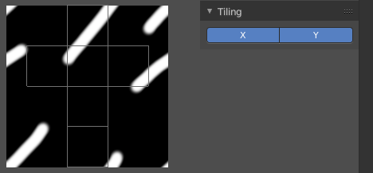
Tiling allows you to draw over the borders and continue the stroke at the other side of the image. You can tile in X and Y direction.

